1. **Shell script to find passing grades of students using Single Decision if statement**

**CODE:**

echo “Enter Percentage:”

read marks

if(($marks < 30))

then

echo "Grade: Fail"

fi

if(($marks >= 30 & $marks <= 40))

then

echo "Grade: Pass"

fi

if(($marks > 40 & $marks <= 60))

then

echo "Grade: Good"

fi

if(($marks > 60 & $marks <= 80))

then

echo "Grade: Very Good"

fi

if(($marks > 80 & $marks <= 100))

then

echo "Grade: Excellent"

fi

**OUTPUT:**

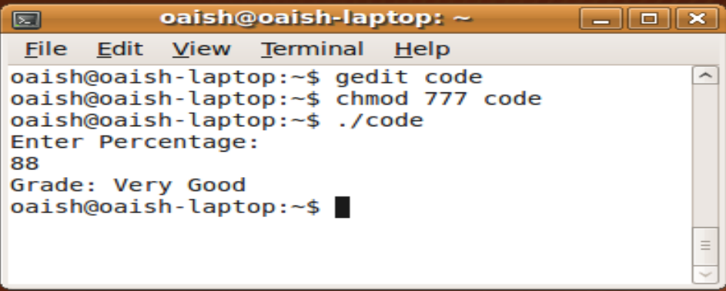

**2. Shell script to find passing grades of students using Double Decision if statement.**

**CODE:**

marks=29

if(($marks < 30))

then

echo "Grade: Fail"

fi

if(($marks >= 30 & $marks <= 100))

then

echo "Grade: Pass"

fi

**OUTPUT:**

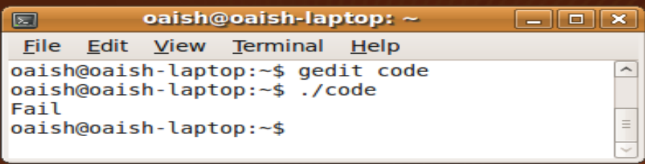

**3. Shell script to find passing grades of students using Multiple if statements**

**CODE:**

marks=55

if(($marks >= 30 & $marks <= 40))

then

echo "Grade: Pass"

elif(($marks > 40 & $marks <= 60))

then

echo "Grade: Good"

elif(($marks > 60 & $marks <= 80))

then

echo "Grade: Better"

elif(($marks > 80 & $marks <= 100))

then

echo "Grade: Excellent"

else

echo "Grade: Fail"

fi

**OUTPUT:**

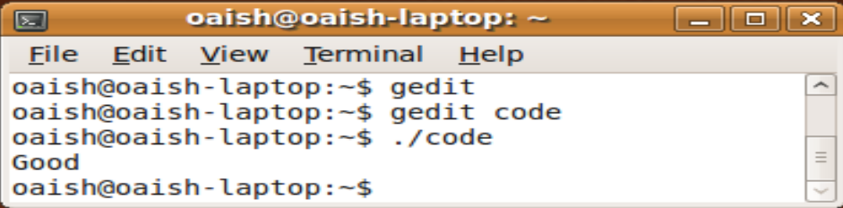

**PRACTICAL RELATED QUESTIONS:**

**1. Shell script to demonstrate nested if statements**

**CODE:**

echo "Enter any Number: "

read n

if [ $n -lt 0 ]

then

echo "Its Negative!"

elif [ $n -eq 0 ]

then

echo "Its Neither Positive Nor Negative!!"

else

echo "Its Positive!"

fi

**OUTPUT:**

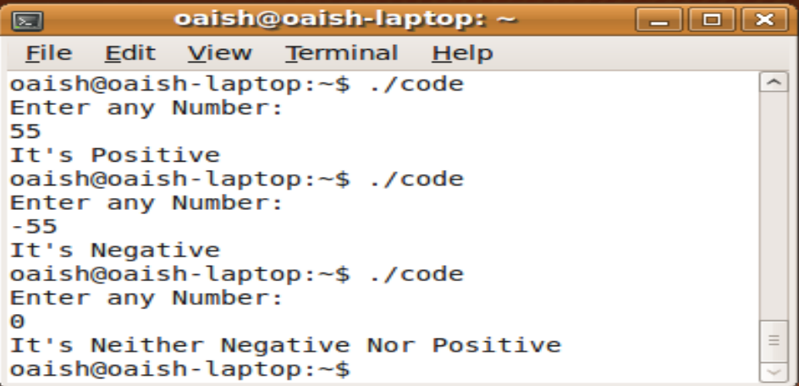

**2. Shell script to find greatest number among given three numbers.**

**CODE:**

echo "Enter num1: "

read num1

echo "Enter num2: "

read num2

echo "Enter num3: "

read num3

if [ $num1 -gt $num2 ] && [ $num1 -gt $num3 ]

then

echo –e “$num1 is the greatest”

elif [ $num2 -gt $num1 ] && [ $num2 -gt $num3 ]

then

echo –e “$num2 is the greatest”

else

echo –e “$num3 is the greatest”

fi

**OUTPUT:**

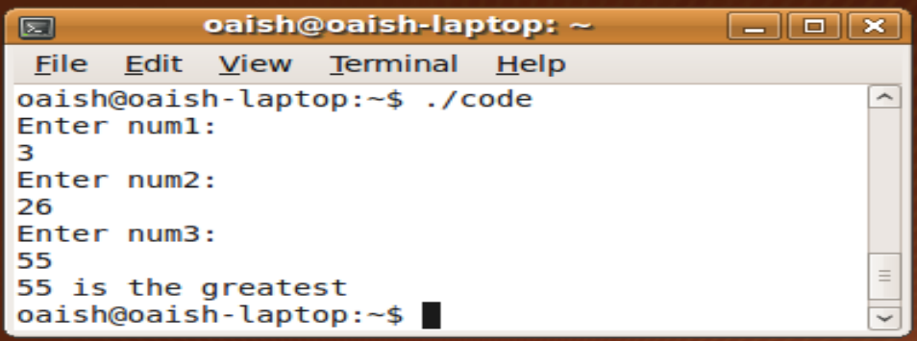

**EXERCISE:**

**Correct the following script and write its output**

1. **If [ ! -r "$1" ] then echo "File $1 is not readable-skipping." fi**

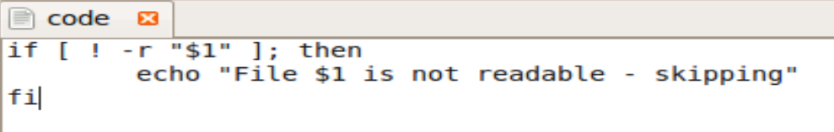

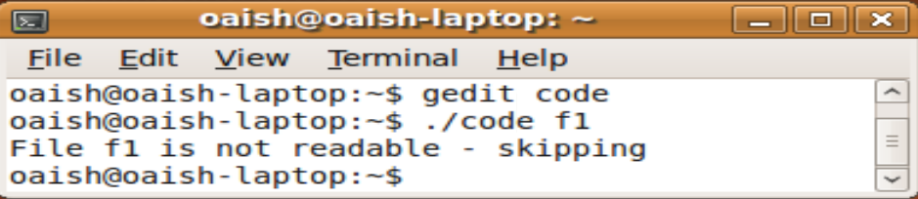

1. **if[ “$1” -nt "/etc/passwd" ]; Then**

**echo "$1 is a file which is newer than /etc/passwd."**

**Fi**

